Slide 1 | 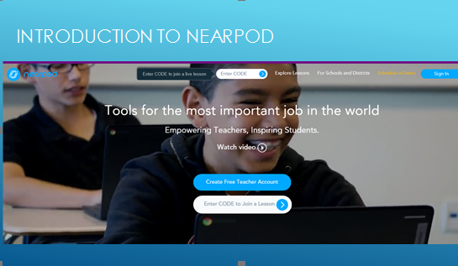 | Introduction to Nearpod greeting screen
Slide 2 | 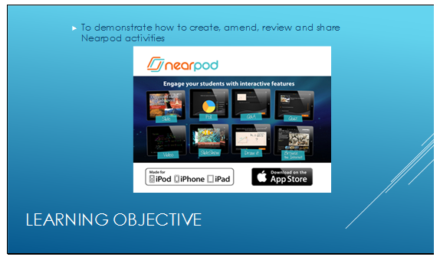 | Explain todays ILO
Slide 3 | 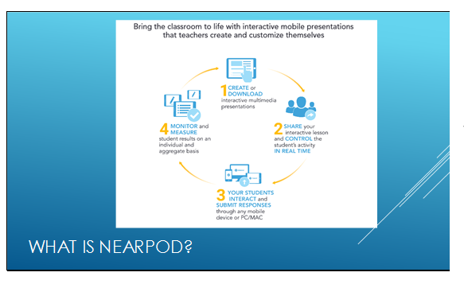 | Explain briefly the Nearpod is a way to bring boring presentations to life with real-time interactive activities that can viewed on your audiences devices and can be shared with others
Slide 4 | 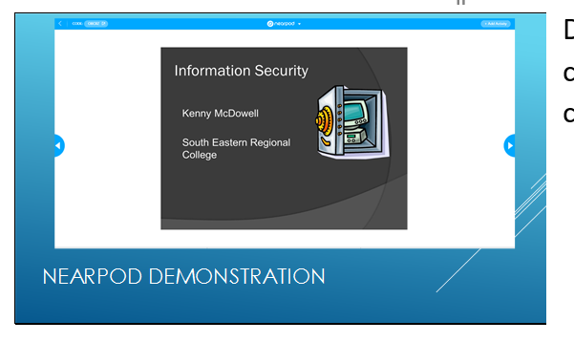 | Demonstrate a nearpod activity to the class –with a computer and a concurrent mobile device
Slide 5 | 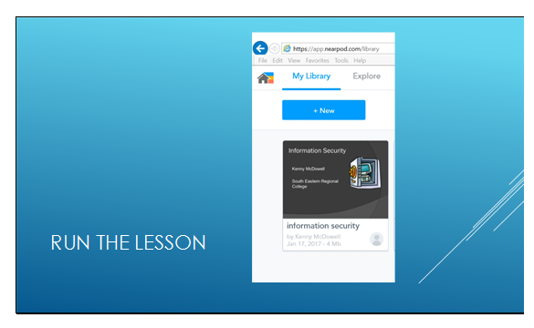 | Show the audience how you run a lesson from Nearpod
Slide 6 | 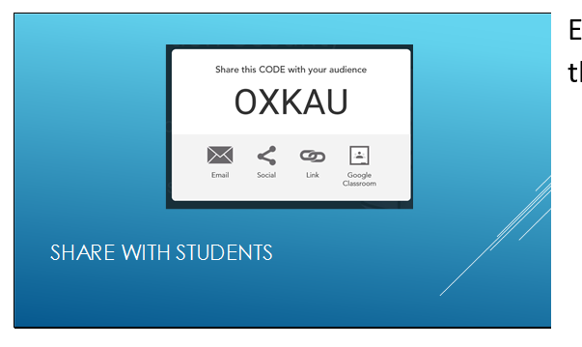 | Explain how the audience can access the lesson
Slide 7 | 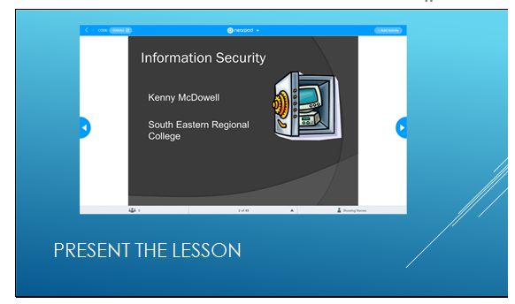 | Present a previously created lesson from pc and present on to the screen in the classroom
Slide 8 | 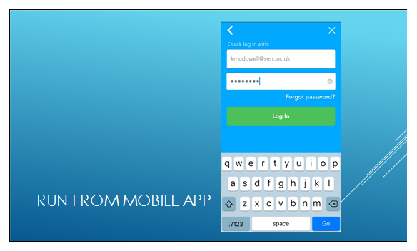 | Run the app from a mobile device
Slide 9 | 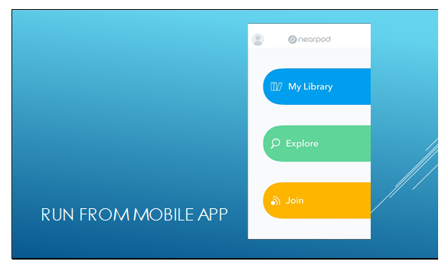 | Access your library
Slide 10 | 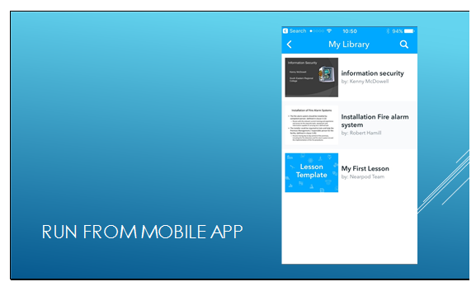 | Run the lesson on your mobile device that is also currently already running on the pc
Slide 11 | 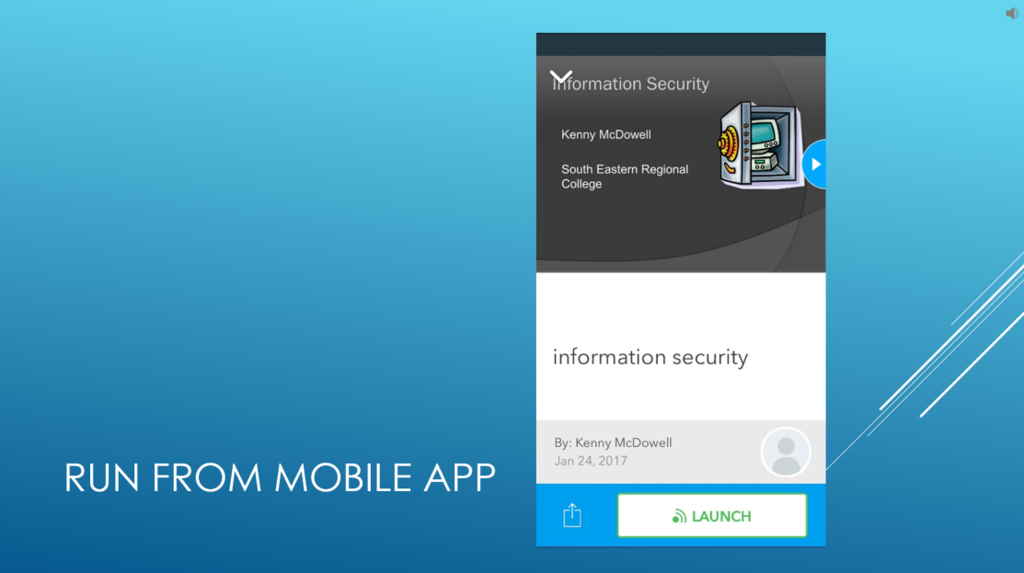 | Launch the lesson
Slide 12 | 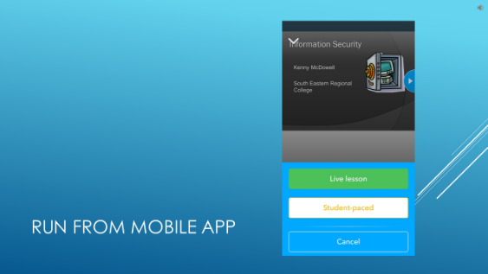 | Run as a live lesson at teacher pace
Slide 13 | 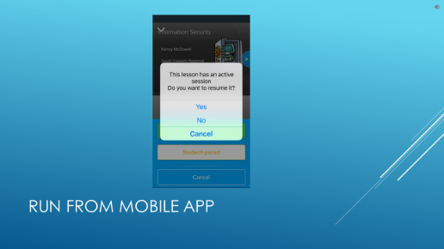 | Resume the lesson by selecting Yes to continue with the lesson that is also running on the pc and is being projected on the classroom screen
Slide 14 | 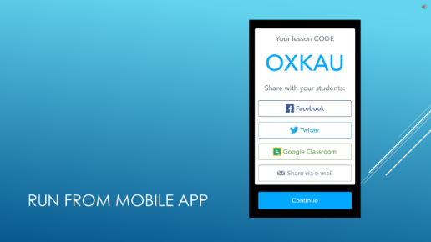 | Code for students if needed click continue
Slide 15 | 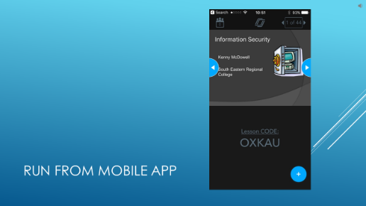 | Navigate through the lesson with your mobile device
Slide 16 | 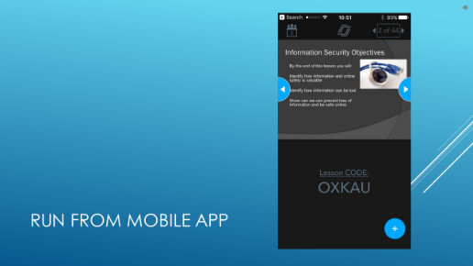
Slide 17 | 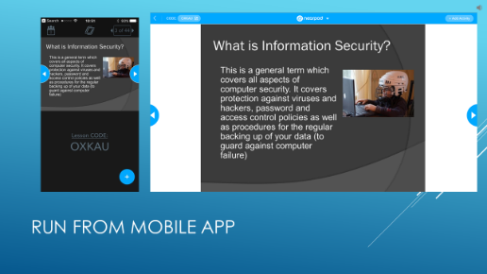 | Students will see the lesson on their own screens
Slide 18 | 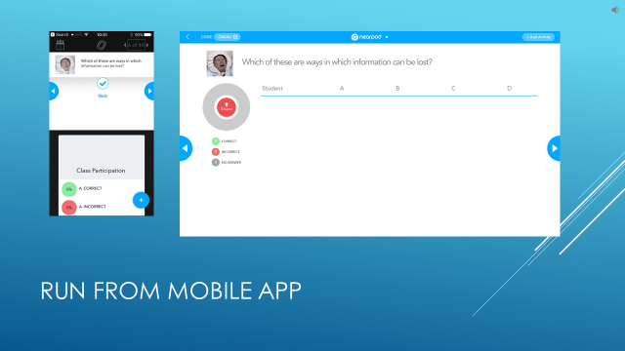 | A quiz slide is being presented you can see the attempts on your device
Slide 19 | 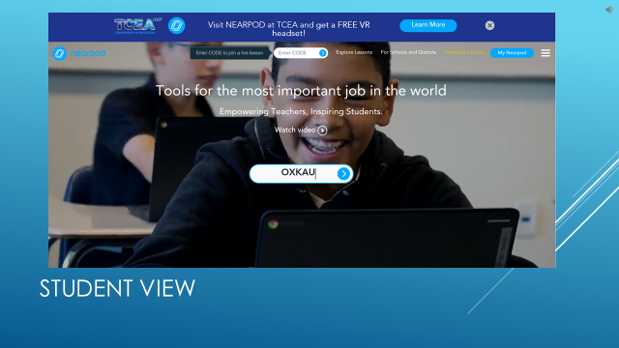 | This is the student view – they go to the Nearpod student website and enter the code you provided
Slide 20 | 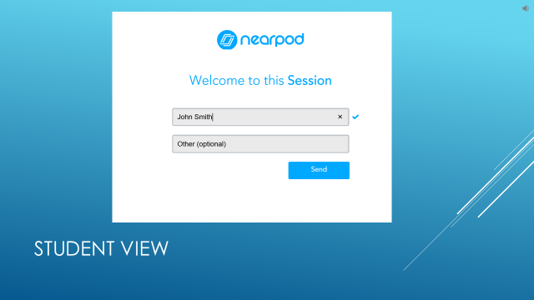 | Students enter in their name – ensure they put in their proper names
Slide 21 | 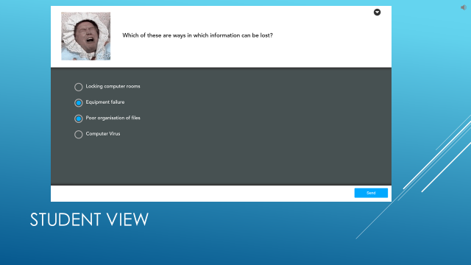 | This is the question slide that is being presented from the teachers device students enter their answers and click next
Slide 22 | 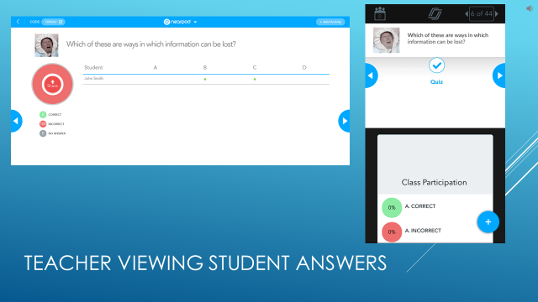 | You can share the answers with your class from the pc or your mobile device
Slide 23 | 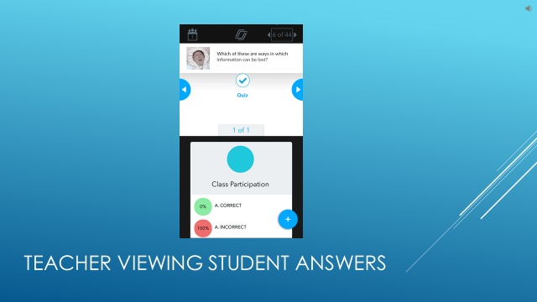 | Swipe up on your mobile device to share the results with your audience
Slide 24 | 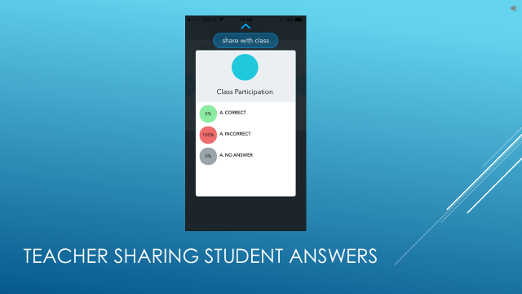 | The audience can view the results swipe down to un-share
Slide 25
Slide 26 | 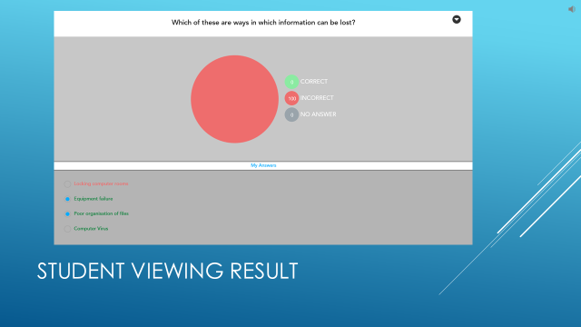 | The student can see the whole class result for the question in the top pane and their individual result in the bottom pane
Slide 27 | 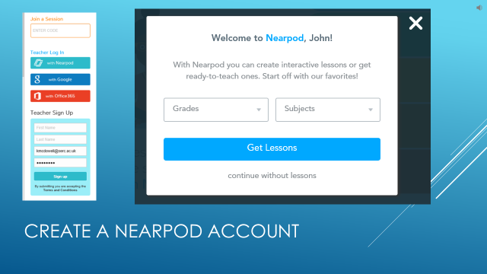 | To create these lessons first create an account at Nearpod.com and complete the sign up form.
Slide 28 | 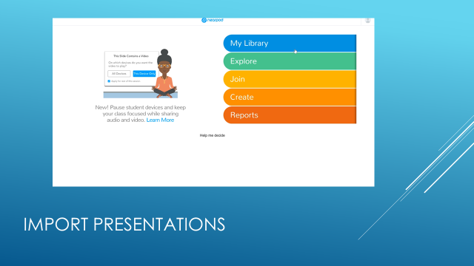 | On the home page click on create and use the import wizard too drag and drop presentations in to your lesson watch the accompanying webinar presentation video to see how this is done
Slide 29 | 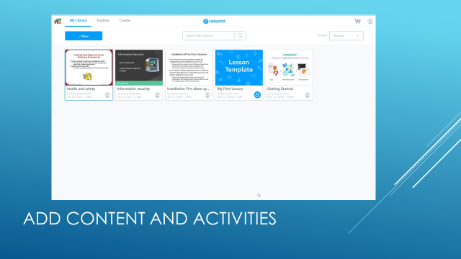 | In your library you will see your imported presentation watch the accompanying webinar presentation video to see how this is done
Slide 30 | 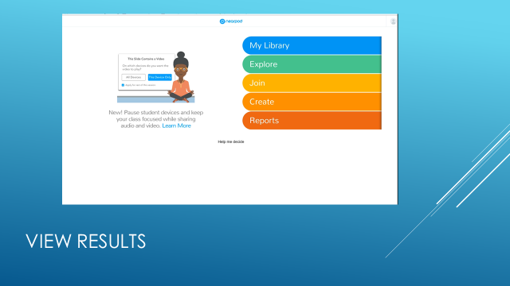 | Click on reports and select the lesson that has been attempted by students to watch the accompanying webinar presentation video to see how this is done
Slide 31 | 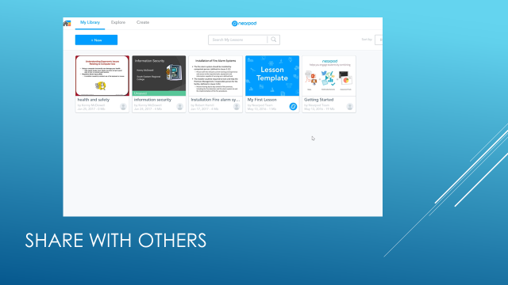 | You can share you lesson with other teachers watch the accompanying webinar presentation video to see how this is done
Slide 32 | 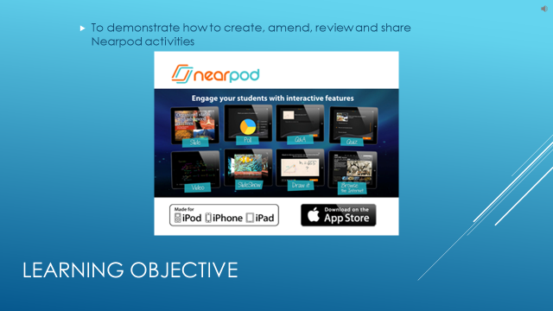 | Revisit your learning objective

