Google Docs for classroom
Student Handout

Google Docs is a suite of online tools. Your documents are stored online and you can share your documents with other users. This allows you to collaborate online.

In order to use Google Docs, you must have a Google account. In order to preserve your privacy it’s important that you do not use your own, personal Google account. You will need to create another account that you will use for course work.

This handout will take through these steps and contains guideline on how to use this facility.

Setting up a new account

In Google Chrome, the tiles on the top left of the screen and click on My account:
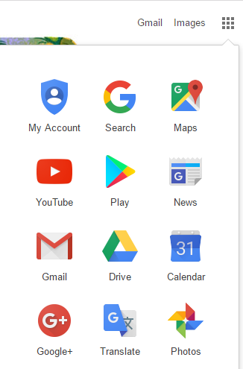

On the next screen select ‘create your google account’.
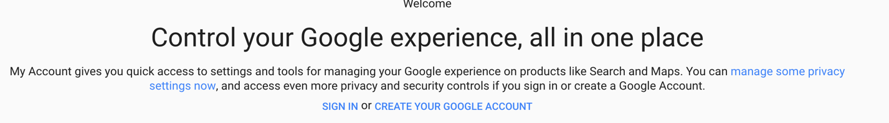

At this point, you must make sure that your data is protected. In order to do so, avoid using your full name and date of birth.

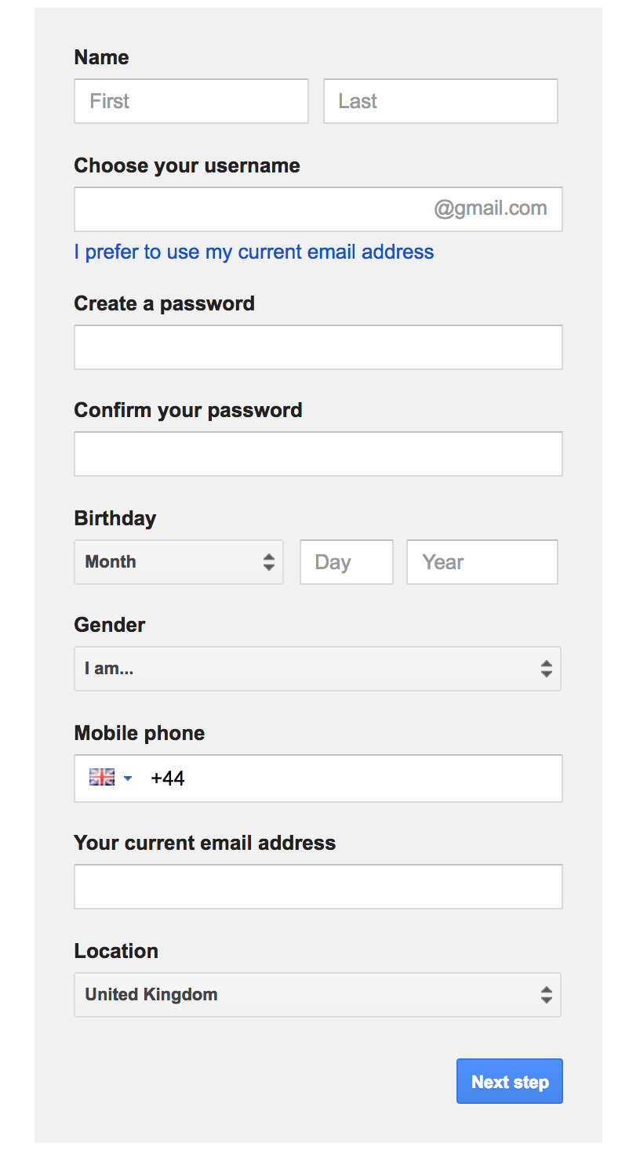

You will have to use your own phone number to register. You should then delete from your profile.

You should use their college email address. This a good policy in case you forget your password.

Once the registration process is finished, you and your students can start working with the google apps. The most likely apps to be used are Docs, Sheets and Slides.

Creating a document

Once logged in, go to Drive:

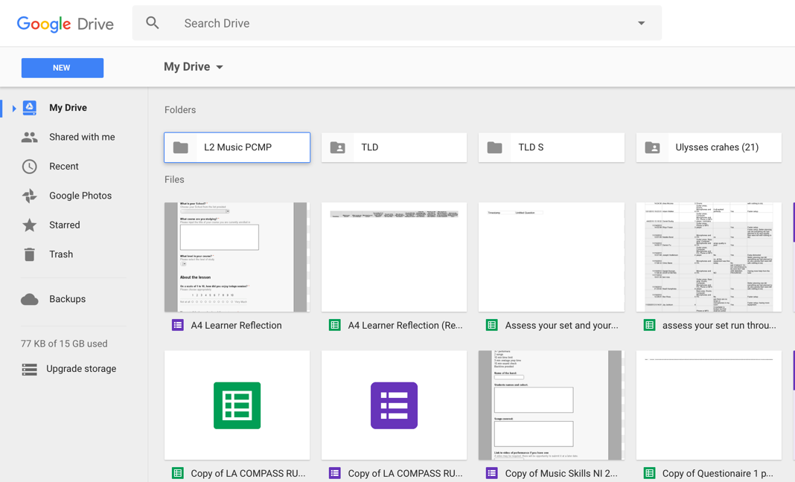

Click on NEW

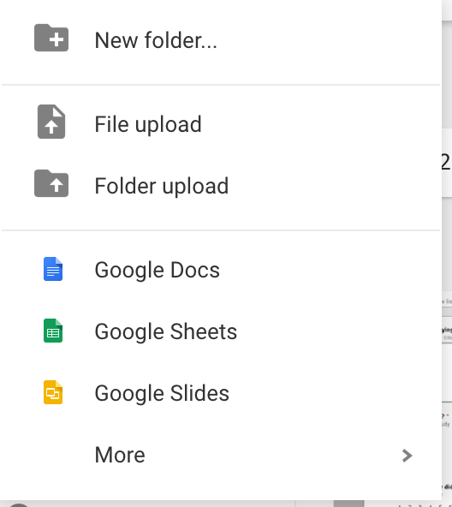

Choose either Docs, Sheets or Slides.

Sharing documents and collaborating

Every document you will create will have the same Sharing and Collaboration options. What makes Google Docs so attractive and powerful is your ability to share documents, discuss changes and content, and trace history of amendments.

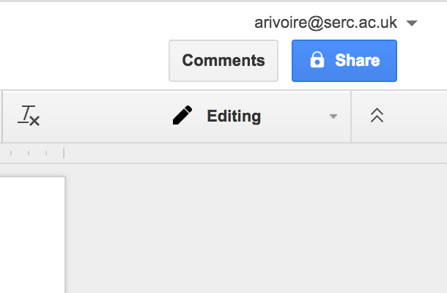

Sharing a document:

Clicking on the Share icon on the top right of the browser’s screen open this dialogue window.

Sharing a document is as simple as entering the email address of the people you want to collaborate with.

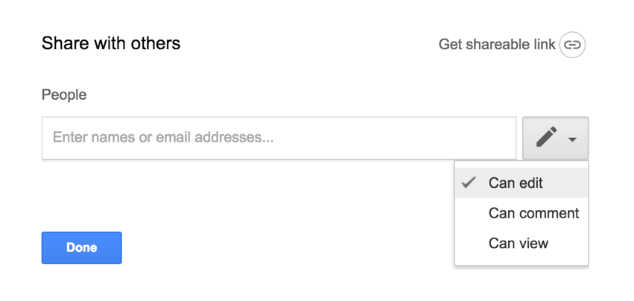

Attention should be paid the level of access to your collaborators. You can decide they can view only, can view and comment, or have full viewing, commenting and editing rights.

Once a document is shared, it can be edited and collaborators can start using the comment section.

The Comments function is activated by clicking on the Comments button on the top right corner of the browser screen, next to the Share button

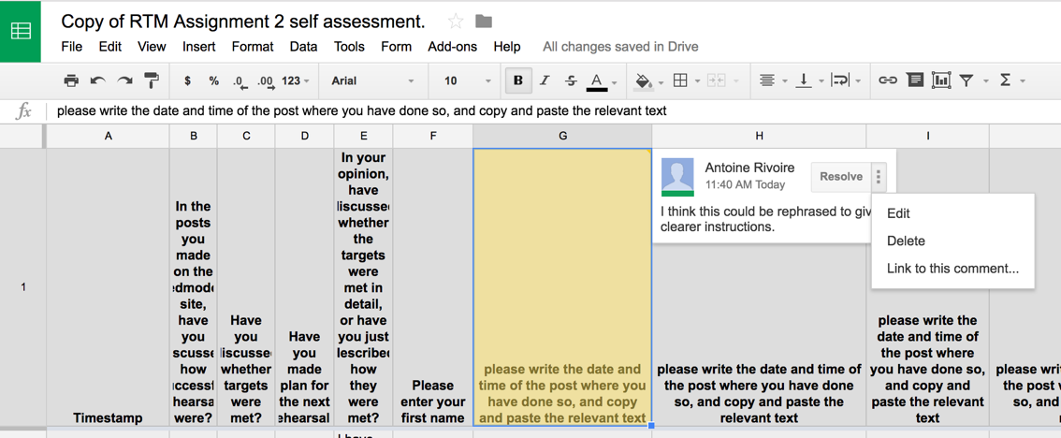
In Google sheets, comments are attached to cells.

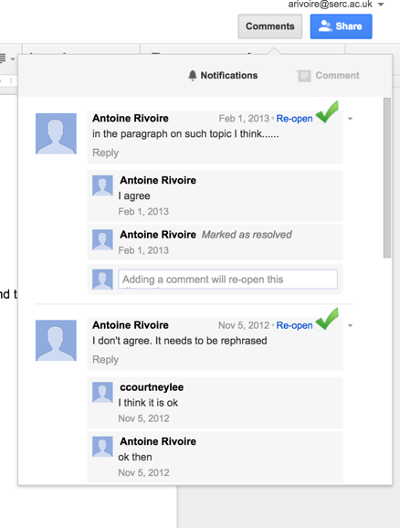

Comments can be marked as solved once this particular topic of discussion is finished.
Comments can also be edited, deleted or liked.

Revision History

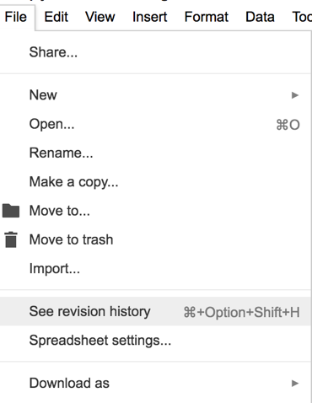
In Googles Docs, Sheets and Slides, work is attributed to its author. You can view a revision history of the document and see who has contributed what. This ensures that participants to an activity cannot take credit for work they did not take part in.

In this example you can see the edited text. The edit is clearly attributed to one of the authors. Clicking on the boxes in the revision history you see who contributed what to the document.

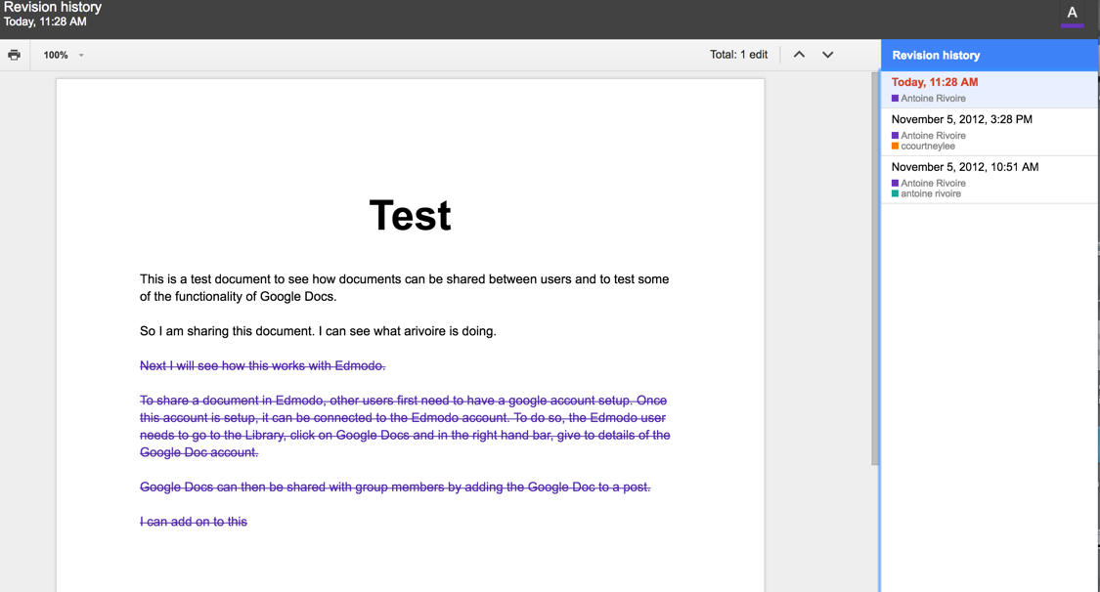

Netiquette

As you work and collaborate online, it is important to observe a few simple rules to make sure that communication is productive. Online there is no context for people to judge if you are joking, or mean something lightly. Therefore, you need to adjust how you communicate.

Here a few rules you should apply:

- Be constructive: If you disagree with someone, be mindful of the way you say it. Suggesting improvement or alternatives are the best to stay constructive and productive.

- Use appropriate language. Avoid rude or coarse language. Use good grammar and spelling.

- Only discuss topics related to the activity. Keep to the subject at hand. If you need to raise a different subject, open a new comment.

- Avoid sarcasm. Sarcasm does not translate well online and can be misconstrued.

- Be concise. Try to make your point clearly, and without superfluous information.

- Respect other’s privacy. Do not publish other people’s details such as phone numbers or addresses. For that matter, you shouldn’t your own either.

