Google Docs for classroom
Teacher Handout

Google Docs is a powerful suite of web-based tools. It offers many opportunities to leverage and implement 21st skills. With this tool you can easily devise and implement synchronous and asynchronous activities, use it as part of a distance or blended learning strategy, making it a very attractive product for educators.

Google is of course very aware of this and it offers a dedication education package called G Suite. The main difference between G Suite and using normal google docs is privacy. This is something you must consider before you decide to use Google Docs. Your students will be subjected to the same privacy settings as any other Google customer. It is therefore important that student data used to create account complies with your institution policies.

Chances are you and your students already have a Google account. This account is private and may include data such as phone number, addresses, or be linked to social media. Furthermore, the privacy settings for these personal accounts may not be suitable in a classroom context. By using private, personal account, you risk being in breach of your employer’s data management policies.

Therefore, you may not want to use these accounts. Instead, you may to create specific accounts for class activities. There is one more caveat: google uses mobile phone activation and only allows a restricted amount of accounts to be linked to one phone number. There is a risk that someone cannot create a new account.

This document will take you through the initial set-up.

Setting up a new account

In Google Chrome, the tiles on the top left of the screen and click on My account:

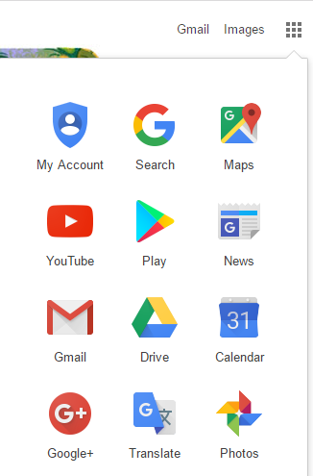

On the next screen select ‘create your google account’.

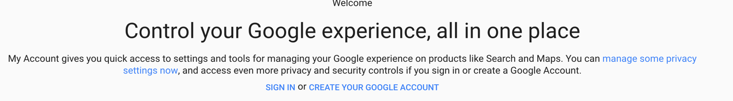
At this point, if you are asking students to create their own accounts, you must make sure that your students data is protected. This might include steps such as asking students not to use their real names and birthdays.

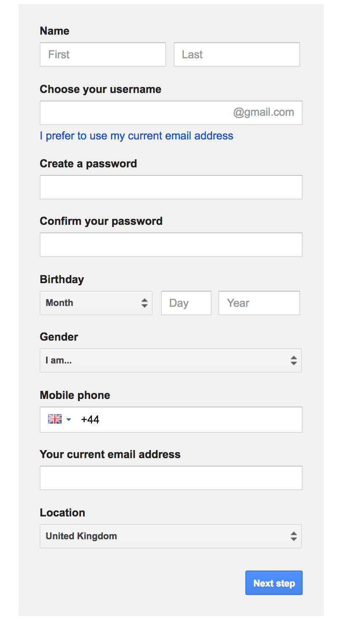

Students will have to use their own phone number to register. The numbers should then be deleted from their profile.

Students should use their college email address. This a good policy in case students forget their password.

Once the registration process is finished, you and your students can start working with the google apps. The most likely apps to be used are Docs, Sheets and Slides.

Creating a document

Once logged in, go to Drive:
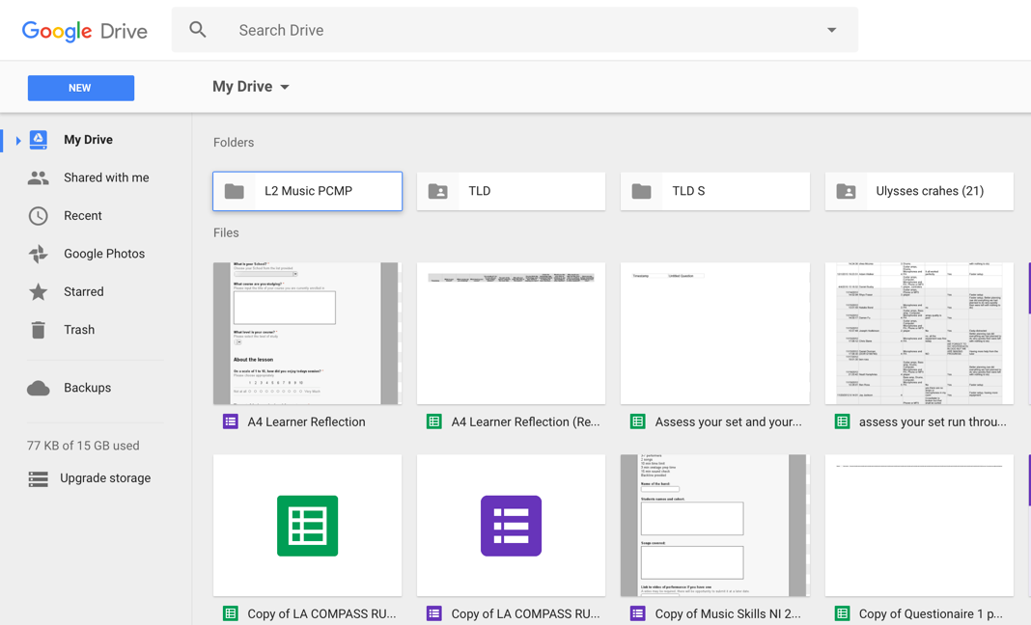

Click on NEW

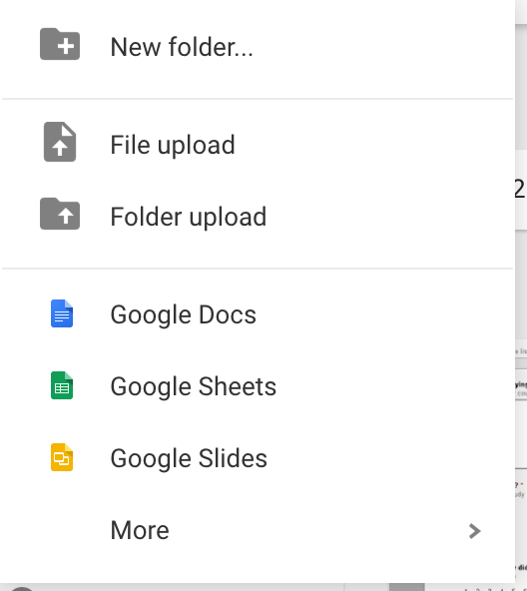

Choose either Docs, Sheets or Slides.

Sharing documents and collaborating

Every document you will create will have the same Sharing and Collaboration options. What makes Google Docs so attractive and powerful is your ability to share documents, discuss changes and content, and trace history of amendments.
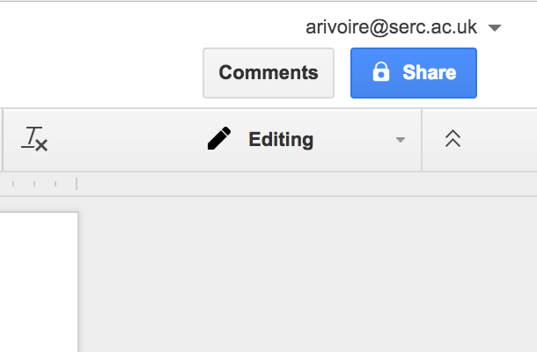

Sharing a document:

Clicking on the Share icon on the top right of the browser’s screen open this dialogue window.

Sharing a document is as simple as entering the email address of the people you want to collaborate with.

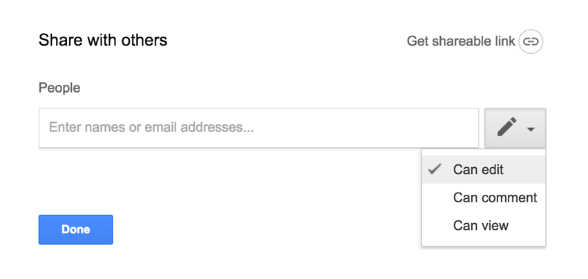

Attention should be paid the level of access to your collaborators. You can decide they can view only, can view and comment, or have full viewing, commenting and editing rights.

Once a document is shared, it can be edited and collaborators can start using the comment section.

The Comments function is activated by clicking on the Comments button on the top right corner of the browser screen, next to the Share button

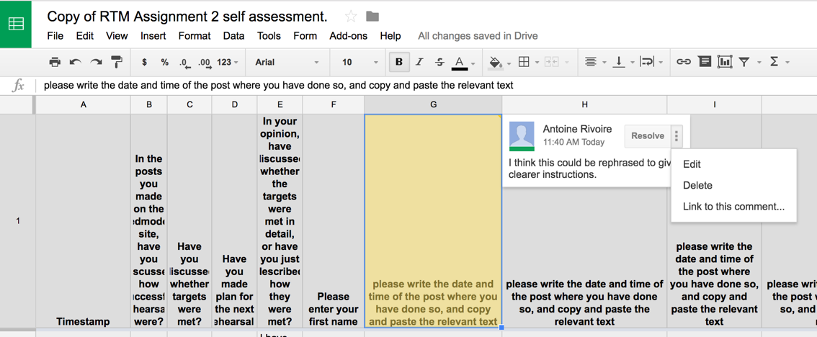

In Google sheets, comments are attached to cells.

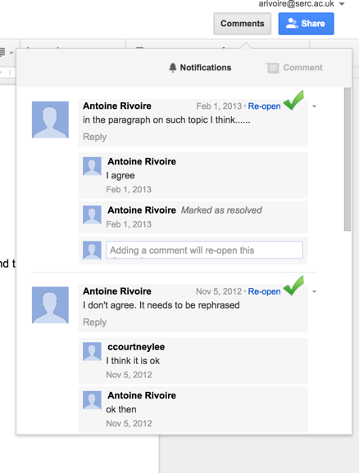

Comments can be marked as solved once this particular topic of discussion is finished.
Comments can also be edited, deleted or liked.

It is important that students using Google Docs in collaborative activities are actively reminded of proper use of commenting function and proper netiquette.

Revision History
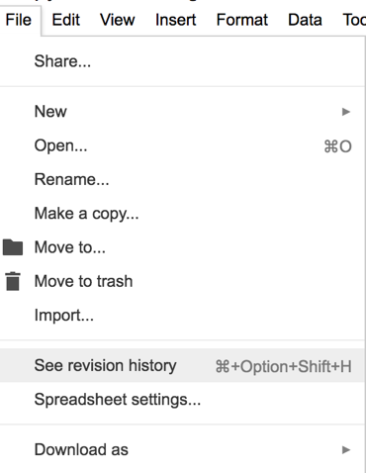

In Googles Docs, Sheets and Slides, work is attributed to its author. You can view a revision history of the document and see who has contributed what. This ensures that participants to an activity cannot take credit for work they did not take part in.

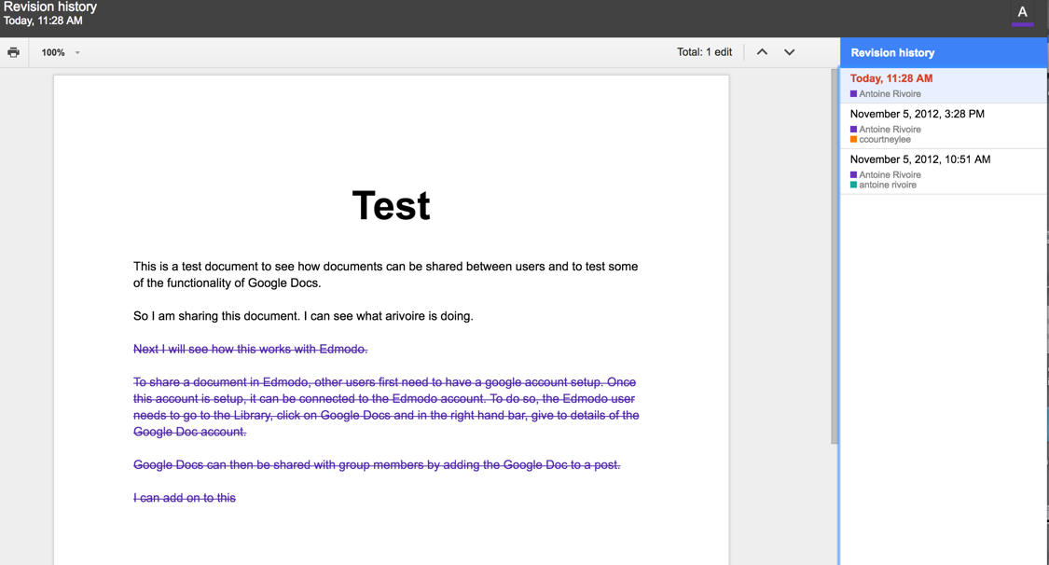
In this example you can see the edited text. The edit is clearly attributed to one of the authors. Clicking on the boxes in the revision history you see who contributed what to the document.

